Thanom Chapakdee (529 words)
Pratuang Emjaroen (1935–)
Pratuang Emjaroen is a member of a wave of self-taught artists in Thailand who gained renown in the 1970s. His works are driven by his concerns about the vicissitudes of life, social problems, nature and Buddhism. A prolific artist, he created a large variety works throughout his career. Pratuang began his career working as a painter of cinema billboards and movie posters. Inspired by the biographic film Lust for Life (1956), about Vincent Van Gogh, Pratuang developed an interest in becoming a visual artist and began studying painting independently. Being a self-taught artist could have been an obstacle to his career in challenging Thailand’s traditional art institutions. Fortunately, Pratuang was able to overcome this in developing his own inimitable style in painting, drawing and poetry. Having struggled to become a renowned artist, Pratuang established the Dhamma Group in 1971, and was able to convince many artists to join, thereby increasing his own reputation. In 1967, he a won Silver Medal from the National Exhibition of Arts, and in 1968, 1974 and 1995 won Bronze Medals. Pratuang received the National Artist of Thailand Award in Visual Art in 2005.
Pratuang was born in Thonburi and grew up in an area of abundant fruit framing and rice fields. This landscape became deeply embedded in his character and indelibly etched in his memory and subconscious. When he was 16 he worked with his brother in a local cinema painting cinema billboards and posters for 8 years, before he left and to become an artist. His early paintings (1960-1970) concentrated on the essence of life and nature, for example, The Black Sun (1963), Life (1966) and The Family (1966). During the 1970s, Thailand’s political crisis and social problems encouraged him to create works that included religious symbolism and used rural and political references to criticise the political climate, for instance Dharma and Adharma (1973-1974), Grains, Sickle, and Lamp of Clay (1976), The Seni Stone (1976), Red Morning-Glory and Rotten Gun (1976), Sacrifice (Fasting Buddha) (1976), Madman Loves his Country (1976).

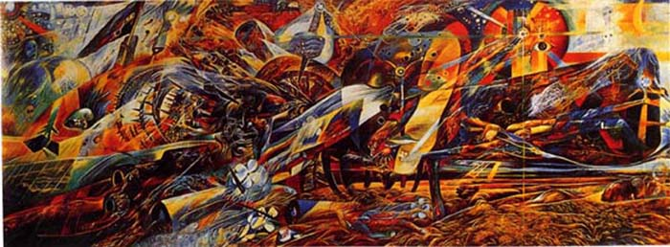
Pratuang Emjaroen, Dharma and Adharma, 1973-1974, Oil on canvas, 200x500 cm.
From 1981-2000s, Pratuang’s work focused on the characteristics of experience and emphasised abstract forms of nature, while also including human figures, as in The Agriculture King (1987), Poet Chang (1989), and Dances of the Emerald (2000). Pratuang is an outstanding artist with a confident style incorporating nature, religion, modes of life and philosophical ideas. He lives and works at Emjaroen Gallery in Kanchanaburi Province.

Reference and further reading.
-----. (1984) Dhamma Vision, (exhibition catalogue), Visual Dhamma Gallery, Bangkok, United Production.
Clark, John. (1998) Modern Asian Art, Honolulu: University of Hawai’i Press.
Emjaroen, Pratuang; Sinsakul, Tasanee; and Viravong, Sumalie , (1990). Pratuang Emjaroen : His Life and Artistic Work, 1962-1990. Bangkok: Saha International.

Jataisong, Chookiet. (2001). Sen See Hang Cheevit : Pratuang Emjaroen (Lines Colors of Life : Pratuang Emjaroen), Bangkok: Ming Mitr.

Poshyananda, Apinan. (1992) Modern Art in Thailand: Nineteenth and Twentieth Centuries. New York: Oxford University Press.

